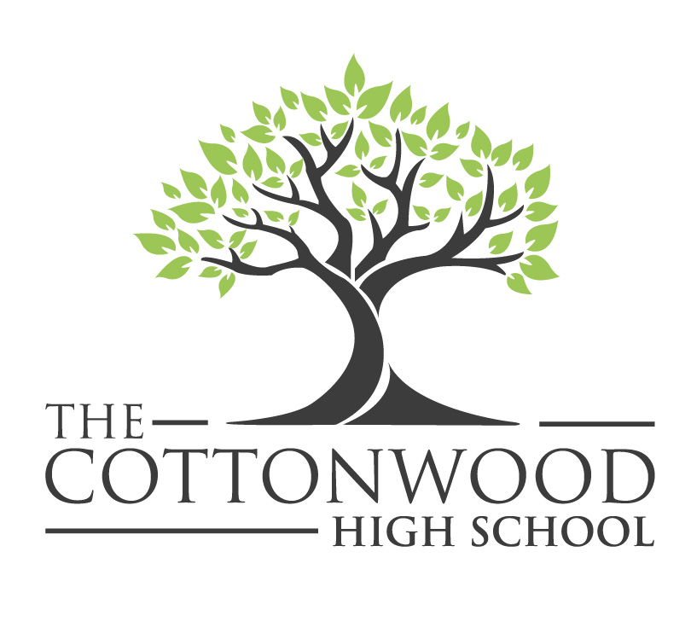
Course Catalog
2021-2022

Table of Contents
Montessori Principles 2
The Cottonwood High School Graduation Requirements 3
English 5
Mathematics 7
Science 9
Social Sciences 10
Visual and Performing Arts 12
Foreign Language 13
Montessori Electives 14

Montessori Principles

The Cottonwood School course of study blends Common Core, project-based learning, and 21st Century Skills with the philosophy of Montessori. Incorporating TCS values with the spiraling curriculum deepens understanding leading to student agency—where a student has a growth mindset to take charge of their own learning.

Community Meetings

In a relaxed, open environment students are able to respectfully express themselves. Community meetings support student agency through mindful engagement as a participant and through leadership development as a facilitator.

Advisory

Advisory is all four years with the same group of students and same advisor. Advisors help students find educational resources, assist students to target key academic learning goals, work with mentors to ensure the rigor of internships, and actively involve parents in their student's education.

Collaboration/Garden/Personal-Reflection

Time built-in to the daily schedule allows for individual and/or small group tutorial time for students (with teacher guidance when needed).

Field Studies

To foster agency, students are encouraged to explore their own interests by participating in week-long field studies linked to various themes and academic work. These may include mini courses, local and international trips.

Service Learning

Service learning provides opportunities for students to become knowledgeable in specific areas of interest while serving local and global communities.

The Cottonwood High School Graduation Requirements
TCS Graduation Requirements
English | 40 credits
History/Social Science
World History  US History  US Government  Economics | 10 Credits  10 Credits  5 Credits  5 Credits
Mathematics (must include Algebra 1) | 20 Credits
Laboratory Science
Integrated Physical Science  Biology  Chemistry | 10 Credits  10 Credits  10 Credits
Visual and Performing Arts/Language Other Than English | 10 Credits
College Preparatory Electives | 90 Credits
Total Credits Required | 220 Credits

By Graduation, All Students Will
Plan and participate in one field study a year
Attempt an independent Design Thinking venture
Give multiple presentations including performances to the community
Plan and participate in service learning each year

A-G College Entrance Requirements
Social Science  “A” Requirement | 2-years
English  “B” Requirement | 4 years college preparatory English
Mathematics  “C” Requirement | 3 years, two years of algebra and one year of geometry  4 years recommended
Science  “D” Requirement | 2 years with lab  3 recommended
Language Other Than English  “E” Requirement | 2 years of the same language  3 years recommended
Visual and Performing Arts  “F” Requirement | 1 year
Electives  “G” Requirement | 1 year

English

Composition and Communication
Meets B-English Requirement
10 Credits

Composition and Communication prepares students to master the Common Core State Standards. The course is a survey of historical and culturally significant works and informational pieces to understand how different structures are used to communicate meaning. Writing as a process of self-reflection, expression, and communication is a key component through argumentative, narrative, expository and literary analysis. Student will be working in cooperation with other classes emphasizing cross-curricular units, activities, and projects with a shared theme.

World Literature
Meets B-English Requirement
10 Credits

World Literature is a study of literature from ancient time through the present. With emphasis on major authors and literary trends, all forms of literature will be covered, including poetry, prose, and drama. Discussion and written assignments will stress insight into the works and the correlation of history, culture, literature, and other fine arts. Emphasis will be placed on critical, analytic reading skills, participation in-depth, constructive class discussion, and critical, evaluative writing. Student will be working in cooperation with other classes emphasizing cross-curricular units, activities, and projects with a shared theme.

American Literature
Meets B-English Requirement
10 Credits

American Literature is a study of works from pre-colonial America to the present, examining important themes in American culture, including the American Dream, modernism, individuality, mobility, race, the Westward Expansion and the immigrant experience. Students will engage in critical analysis of literary and expository texts (e.g., novels, short stories, plays, works of nonfiction, poetry and digital media) while becoming more aware of cultural and ethnic diversity, values, customs and beliefs in America. Students develop as critical readers and skilled writers, honing their listening and speaking skills as they engage in formal academic discourse and examine different perspectives and experiences. Student will be working in cooperation with other classes emphasizing cross-curricular units, activities, and projects with a shared theme.

Multi-Cultural Literature
Meets B-English Requirement
10 Credits

Multi-Cultural Literature students will read and analyze contemporary literature in a variety of genres from multicultural perspectives. Novels, short stories, and poems will be closely examined, not only for their plot, character, literary devices, and thematic development, but also in light of their cultural context. Articles, essays, and other non-fiction texts will be examined for their content, rhetorical devices, and political/philosophical assumptions. Students will begin to see literature as a vehicle for understanding global issues. Student will be working in cooperation with other classes emphasizing cross-curricular units, activities, and projects with a shared theme.

Mathematics

Pre-Algebra
10 Credits

Pre-Algebra is designed to prepare students for Algebra 1 with emphasis on foundational skills, student discourse, visual representations, and relational understandings. Topics covered include integers, equations, fractions, the coordinate system, and linear equations. Upon completion of Pre-Algebra, students will be prepared to enroll in Algebra 1.

Algebra 1
Meets C-Mathematics Requirement
10 Credits

Algebra 1 provides the foundation skills required for success in high school mathematics. The primary goal in Algebra 1 is to help students transfer their concrete mathematical knowledge to more abstract algebraic generalizations. Students explore the topics that include recognizing and developing patterns using tables, graphs and equations. Students will apply mathematical properties to algebraic equations. Students will solve problems using equations, graphs and tables to investigate linear relationships. Throughout this course, students will develop learning strategies, critical thinking skills, and problem-solving techniques to prepare for subsequent math courses and college entrance exams. Student will be working in cooperation with other classes emphasizing cross-curricular units, activities, and projects with a shared theme.

Geometry
Meets C-Mathematics Requirement
10 Credits

Geometry presents the major skills and concepts necessary for a student to describe and measure their world. The course develops an understanding of the key concepts: constructions, transformations, parallel and perpendicular lines, right triangles, theorems involving proofs, trigonometry ratios, perimeter, area, volume, and circles. The students will use modeling to extend their understanding of the concepts through real world examples. Throughout this course, students will develop learning strategies, critical thinking skills, and problem-solving techniques to prepare for subsequent math courses and college entrance exams. Student will be working in cooperation with other classes emphasizing cross-curricular units, activities, and projects with a shared theme.

Algebra 2
Meets C-Mathematics Requirement
10 Credits

Algebra 2 provides a review and extension of the concepts taught in Algebra 1. Topics covered will include equations and inequalities, coordinates and graphs, general functions, polynomial and rational functions, exponential and logarithmic functions. Trigonometric functions of angles and of real numbers, analytic trigonometry, systems of equations and inequalities, sequences and series. Throughout this course, students will develop learning strategies, critical thinking skills, and problem-solving techniques to prepare for subsequent math courses and college entrance exams. Student will be working in cooperation with other classes emphasizing cross-curricular units, activities, and projects with a shared theme.

Pre-Calculus
Meets C-Mathematics Requirement
10 Credits

Pre-Calculus is an advanced level of mathematics that combines algebraic, geometric, and trigonometric techniques. Students will strengthen their conceptual understanding, mathematical reasoning, and problem-solving skills. By the end of the course, students will be prepared to study college-level calculus. Students will understand how mathematical concepts can be used to model real-world problems. The course is designed to develop a student’s critical thinking in the analysis of functions and function modeling.

Statistics
Meets C-Mathematics Requirement
10 Credits

Statistics is a step-by-step approach to the beginning statistics course to students whose mathematical background is limited to basic Algebra. This course follows non-theoretical approach without formal proofs, explaining concepts intuitively and supporting them with abundant examples. The application spans a broad range of topics certain to appeal to the interests of students of diverse background.

Science

Biology
Meets D-Science Requirement
10 Credits

The intent of Biology is to give students a greater appreciation of the implications of the power and limitations of science while meeting the Next Generation Science Standards. This class is lab-based in nature and topics covered will include: cell biology, genetics, ecology, evolution and human impacts on the natural world. In addition, students will be expected to work in cooperation with courses emphasizing cross-curricular units, activities and projects within a theme.

Chemistry
Meets D-Science Requirement
10 Credits

The intent of the Chemistry is to give students a greater appreciation of the implications of the power and limitations of science while meeting the Next Generation Science Standards. This class is lab-based in nature and explores the following topics: matter and its classification, molarity, chemical calculations, the periodic table of elements, chemical bonding, atomic structure, chemical reactions, and acid/base relationships. In addition, students will be expected to work in cooperation with other courses emphasizing cross- curricular units, activities and projects within a theme.

Integrated Physical Science
Meets D-Science Requirement
10 Credits

Introduction to Physical Science is a college preparatory laboratory and math-based science class that prepares students to be successful in college level lab science courses. The course integrates chemistry, physics, Earth, space, and environmental science. It is aimed at building a solid foundation in physical science, integrating an intensive laboratory component that consists of both scientific investigations and designing practical applications to develop student’s proficiency in the science practices. Student-centered labs will emphasize the process of inquiry and critical thinking.

Environmental Science
Meets D-Science Requirement
10 Credits

The intent of the Environmental Science course is to give students an empowering understanding of the rapidly changing world in which we live through a multidisciplinary approach to include earth science, biology, chemistry and physics. As the human population increases, our impact on the environment requires vigorous study in order to design solutions that will ensure the sustainability of the world’s resources, including, but not limited to fossil fuels, alternative energy, agriculture, world’s forestry, biodiversity, climate management and water. The course will also examine environmental economics and policy.

Social Sciences

World History
Meets A-History/Social Science Requirement
10 Credits

World History is a survey course covering the political and philosophical roots of western democracy, the growth of democracy and nationalism in the modern era, the industrial revolution, imperialism and colonization, the two world wars, the Cold War and globalization. In addition, students will be expected to work in cooperation with other courses emphasizing cross-curricular units, activities and projects within a theme.

United States History Model United Nations (CP/Honors)
Meets A-History/Social Science Requirement
10 Credits

The United States History/Model United Nations course will combine United States History curriculum with preparation for and with a goal of participating in local Model United Nations conferences—preparing students to be informed, active, and responsible citizens. The curricular focus of this class will be the events of the twentieth century in the United States. Beginning with the dawn of the 1900s, students will examine the economic and political growth of the US and its emergence as a superpower after WWII.
Economics
Meets G-History/Social Science Requirement
5 Credits

Economics, a one-semester course, provides a comprehensive study of the basic institutions, concepts, principles, and practices of economics. The course investigates the political and economic issues confronting national, state, and local governments. The course includes an analysis of the American free enterprise system through a study of comparative economics and instruction on the international dimensions of economics and the “global” economy. Measurement concepts and methods involving tables, charts, graphs, ratios, percentages, and index numbers are introduced to understand the relationship between economic variables.

Government
Meets A-History/Social Science Requirement
5 Credits

Government is a one-semester course that explores our representative democracy and how our leading voice for freedom in the world depends on our understanding and participation in government, encouraging students to be positive, interested, and to contribute to our diverse world. The development of the Constitution, Bill of Rights, and Federalism as well as a study of political parties, voting and voting behavior, and elections at the national, state, and local levels is studied. Students will analyze the influence of special interest groups and the role of the media in shaping public opinion. The role and the responsibilities of the three branches of government at the national, state, and local levels will be explored. Students will analyze landmark court decisions in terms of civil rights and civil liberties and will study complex contemporary issues that confront national, state, and local governments such as immigration, race, abortion, gender, sexual orientation, and disabilities.

Food and Justice
Meets G-College Prep-Elective Requirement
10 Credits

In the course students engage in research on the roles and meaning of food in their lives, communities and cultures. Students explore the different approaches to our food system and provide a framework for defining and evaluating a "sustainable food system." They evaluate traits of a system that nourishes people, the environment, and the economy (a sustainable system). Students analyze the evolution and newer trends on food production, food science, marketing, consumption, food insecurity, food waste, health and the environment and assess the implications of these trends today. In addition, students will be expected to work in cooperation with other courses emphasizing cross-curricular units, activities and projects within a theme.

Visual and Performing Arts

Theater 1
Meets F-Visual and Performing Arts Requirement
10 Credits

Key objectives of the course are to provide students: an opportunity to develop artistic expression, an appreciation for the art and history of theatre, a sense of cultural involvement and discovery, and basic acting techniques. The course culminates in the actors producing their own theatrical experiences, informed by the activities and research undertaken throughout the course and their understanding of the nature of theatre.

Advanced Professional Theater
Meets F-Visual and Performing Arts Requirement
10 Credits

Theater 2 builds on knowledge and skills introduced in Theater 1. This course focuses on the performance aspect of drama such as improvisation, monologues, and ensemble acting. Emphasis is on all theater fundamentals, historical theater, and theater of different cultures. Students will learn in depth the fundamentals of theater including: theater terms, the development of theater over time, acting techniques, character analysis, stage movement, prop and costume usage.

Technical Theatre
A-G Pending
10 Credits

This is a hands-on course that will introduce students to the behind-the-scenes technical needs in theatrical productions, as well as career options that are available in the theatre. Students enrolled in this course will be exposed to stage and set design and construction, lighting and sound design, costume and make-up design, design history, prop building, stage and theatre management and publicity. Students' work will be showcased formally in school productions throughout the year.

Foreign Language
Spanish 1
Meets E- Language Other Than English
10 Credits

This is one-year Spanish course will introduce students to the culture and history of the Spanish language while actively developing students’ ability to comprehend, read, speak, and write in Spanish. Students will be evaluated for grammar use and structure, comprehension, communication strategies, and cultural awareness.

Spanish 2
Meets E- Language Other Than English
10 Credits

This second-year Spanish course builds upon the content covered in Spanish I. Students' will gain increased familiarity with the history, culture, and language of Spanish-speaking countries. The three modes of communication (Interpretative, Interpersonal, and Presentational) are foundational to this course. Students will review the basic concepts of first-year Spanish, then build on that foundation to develop increased skills and fluency in reading, writing, speaking, and listening. Students will develop vocabulary and be able to talk about things that happened in the past, present, and future. Students will be able to write paragraphs in all studied tenses, read simple stories and articles, and have conversations on known topics with familiar vocabulary.

Montessori Electives

Field Study
2.5 Credits

Students follow their curiosity by participating in week-long field studies linked to various themes and academic work. Under the guidance of an advisor, students plan field studies such as mini courses, local and international trips.

Leadership
Meets G-College Prep-Elective Requirement
10 Credits

ASB Leadership has two goals. One, increase the positive school culture through academic and social events. Two, help students enrolled in the class become more effective leaders. This includes mastery of the following core leadership skills: Communication, planning, organizing, problem solving, constructive feedback and evaluation, writing: critically, reflectively, and persuasively, creativity, professionalism, confidence, public speaking, persistence, and empathy.

Model United Nations
Meets G-College Prep-Elective Requirement
10 Credits

The Model UN elective provides an academic learning experience through the simulation of the structures, processes, and issues of the member nations of the United Nations Organization. The Model UN class offers students a unique opportunity to learn about international relations while stepping into the roles of United Nations delegates.

STEAM
Meets G-College Prep-Elective Requirement
10 Credits

"STEAM" is an acronym for science, technology, engineering, art, and mathematics. In this interactive elective, students will explore the design process to solve problems for the present and future by thinking critically and cultivating a modern skillset. Students can expect to grow in technical knowledge of engineering and tech-based careers; class projects will include 3D printing, website development, content production, robotics, and computing.

